Final project of compute networks

Team members:

Rawan Ashraf mostafa ali  Mohamed khaled abdelhaq  Mahmoud Waleed elsheikh  Hania Waleed elsheikh  Belal Tarek  Nour Mohamed  Yousef Mahmoud Essamt  Ali sayed owes  Ahmed Mohammed Ahmed  Youssef Mohamed | 202505683  202508546  202512172  202507977  202508318  202508631  202506278  202508364  202508166  202508022

TA: Hager Mahmoud _Mariam Emad

Introduction:

Project Scenario: The objective of this project is to design and implement a robust network infrastructure for a university. The university consists of 4 main faculties, where each faculty serves as a separate entity within the network.
Network Scale:
Each faculty consists of 4 floors.
Each floor contains 5 Scientific Labs.
Each lab is equipped with 10 PCs.
Total Scale: The network is designed to handle a large number of end devices, ensuring high connectivity, security, and efficient data flow between different departments and the central administration .

Design Topology:

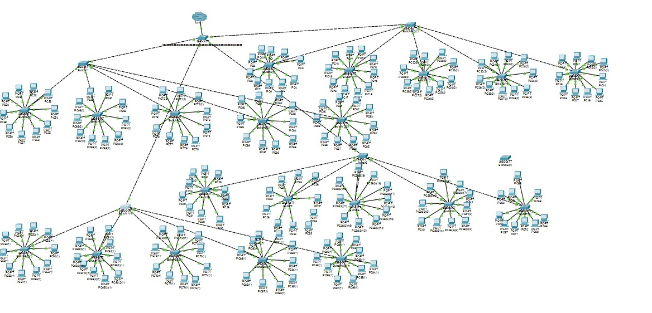

Body Implementation & Technical Details:

A. VLAN Segmentation
To organize the network and reduce broadcast traffic, we implemented Virtual LANs (VLANs). Each faculty is assigned its own VLAN. This ensures that:

Traffic from one faculty is isolated from others for security.

Network management is simplified by grouping users based on their department rather than their physical location.

Trunking Protocol (802.1Q): Configured on the links between switches to carry traffic for all VLANs across the backbone.

B. IP Addressing & Subnetting
We applied a Subnetting strategy to divide the main network address into smaller, manageable subnets.

Strategy: Each faculty was assigned a specific subnet range.

Efficiency: Using Subnetting helped us reduce IP address wasting and improved network security by creating clear boundaries between different departments.

Gateway: Each subnet has a designated default gateway configured on the Layer 3 device to allow inter-department communication.

C. Inter-VLAN Routing
Since VLANs are isolated by default, we configured Inter-VLAN Routing (using a Multilayer Switch or Router) to allow students and staff in different faculties to communicate when necessary (e.g., accessing a central university server).

D. Connectivity Testing (Validation)
To verify that the configuration is correct, we performed the following tests:
Ping Test (Same VLAN): Successful communication between PCs within the same Scientific Lab.
Ping Test (Different VLANs): Successful communication between a PC in one faculty and a PC in another, proving that routing is working correctly.

Trace Route: Used to track the path of the packets and ensure they are taking the most efficient route through the core switches.

